|  |  |  |  |
| --- | --- | --- | --- |
| **Document Number** | **PP4** | | |
| **Document Title** | Ordering | | |
| **Department Ownership** | Physiotherapy | | |
| **Document Type** | Procedure | | |
| **Department Owner** | Jason Ryan | | |
| **Document Author** | Derrick Chan | | |
| **Last Edited By** | Derrick Chan | **Lasted Edited On** | 14/07/2015 |

# Purpose

The purpose of this procedure is to describe the method used within the Physiotherapy Department of REDIMED to monitor and control stock levels and order the supplies required for the operation of the department.

# Scope

This procedure shall apply to the Physiotherapy Department only and be applied to all supplies used and orders completed by this department.

# Reference Documents

# Definitions

**Consumables** – All products (except stationary) used by the physiotherapy department including billable and non-billable items.

**PO** – Purchase Order

# Flowcharts (Other Images)

# Procedures

Ordering for the Physiotherapy Department consumables will be conducted monthly. The following is applicable to REDIMED Belmont, Joondalup and Rockingham.

**PLACING AN ORDER:**

Stock Count:

1. Complete full count of all stock at each premises using the location appropriate stock count spread sheet (Appendices 1-4) on the first Monday of each month.
2. Calculate the stock required from the “Recommended Stock Level.”
3. Recommended Stock Level – Stock Count = stock required
4. Enter the stock required quantity in the “Qty to Order” column.
5. Scan the completed stock count and email to [kspiteri@redimed.com.au](mailto:kspiteri@redimed.com.au)

**Complete PO:**

1. Compile all data from stock counts of Belmont, Joondalup and Rockingham into the Complete Order Template (Appendix 5) in *I Drive: Physiotherapy: Resources: ORDERING: 2. Templates per site*.
2. Save the above spread sheet as “YYYYMMDD Complete Order” into *I Drive: Physiotherapy: Resources: ORDERING: 5. 2015 Ordering* once complete.
3. Print the Complete Order for each supplier.
4. Complete “PO final” (Appendix 6) found in *I Drive: Templates: Accounts Payable* with details of supplier, delivery address and total amount. One will need to be completed for each supplier and separate POs for Belmont.
5. Write “Physiotherapy supplies as per attached” in the descriptions area.
6. Print the PO forms.
7. Attach the appropriate Complete Order to the PO form with matching supplier details.
8. Highlight the supplier and delivery address on the PO form.
9. Highlight the appropriate column and total amount on the spread sheet. For example for a Belmont order, highlight the “Total Qty for Belmont Order” column and “Total cost for Belmont Order” column.
10. Submit all POs to Team Leader for review by Wednesday.

**NOTE: Current monthly budget for stock for the whole department is $7000.**

**Submitting for Approval:**

1. Retrieve all POs from Team Leader
2. Submit to the accounts department to review, approve and assign a PO number.
3. Wait to receive confirmed PO from accounts via email.

**Lodging the Order**

1. Email the Belmont POs from accounts to the appropriate supplier contact. See below for contact details and email template.

|  |  |  |
| --- | --- | --- |
| Supplier | Contact | Email |
| Whiteley Medical | Sharon Eade | [sharon.eade@whiteleymedical.com.au](mailto:sharon.eade@whiteleymedical.com.au) |
| Patterson Medical | Lindsay Hutchison | [lhutchison@ausmedic.com](mailto:lhutchison@ausmedic.com) |
| AOT | Simon Boyd | [simon@aotech.com.au](mailto:simon@aotech.com.au) |

Email Template:

Good Morning/Afternoon (Insert contact name),

Please find attached the (insert month) orders for REDIMED Belmont.

Please quote the PO number in your invoice so that your account can be paid promptly.

Should you have any questions with regards to these orders please do not hesitate to contact me on 08 9230 0900.

Kind Regards

(Insert name)

**NOTE: each supplier email should have PO attached, for Belmont**.

**RECEIVING AN ORDER:**

**Receiving an order in Belmont:**

1. Ensure an invoice is attached to the delivery
2. Use this invoice to mark off everything and ensure the invoice matches the goods received.
3. Scan the invoice
4. Email the invoice to [kspiteri@redimed.com.au](mailto:kspiteri@redimed.com.au)
5. Make note of anything missing
6. Using the “Complete Order” collect all the items required by Joondalup and Rockingham sites.
7. Box up these items and arrange for them to be transported to the appropriate site.
8. Put all remaining stock away at Belmont.

**STOCK CONTROL:**

**Monthly stock level check:**

1. Open Genie-REDiMED program
2. Log onto Genie with your name and password, press ok.

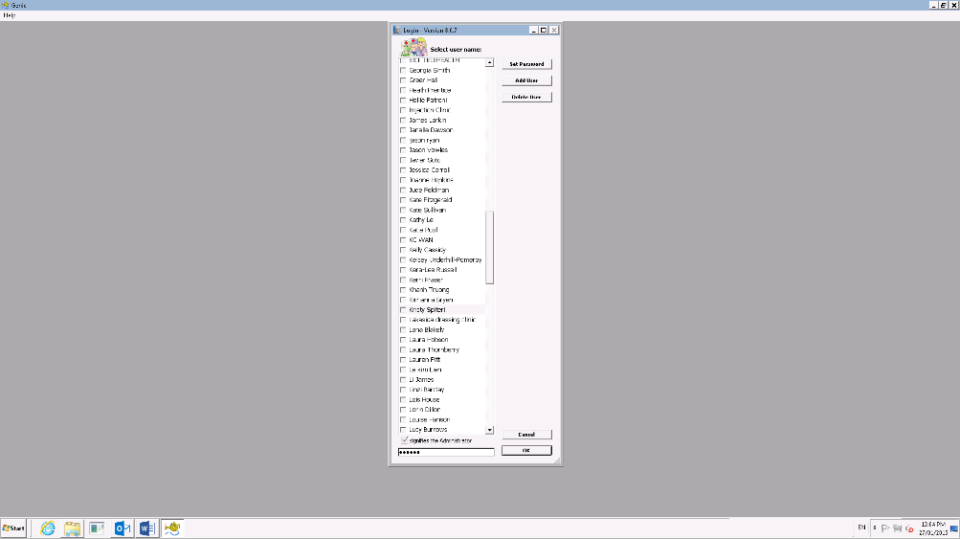

1. Select REDIMED Pty Ltd Belmont and press select.

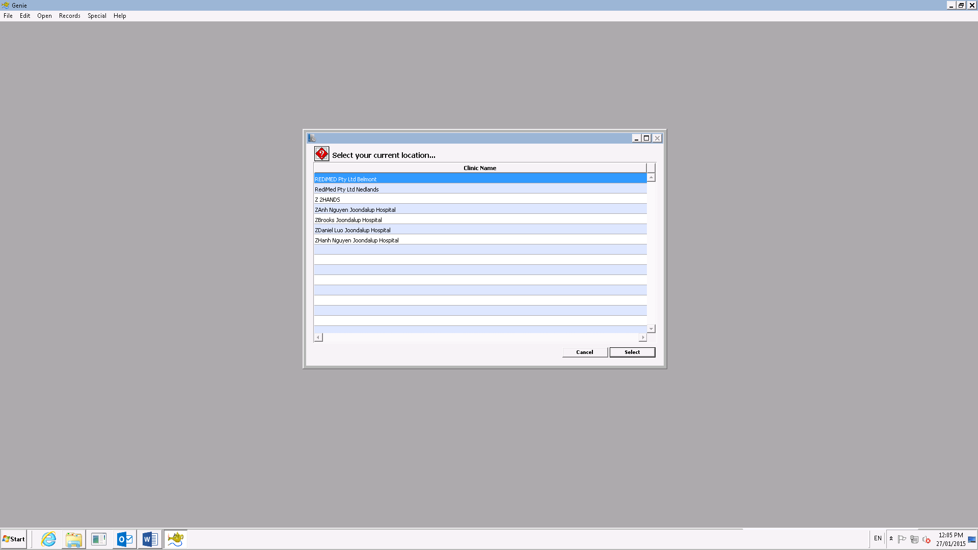

1. Click on Open and select Stock Control.

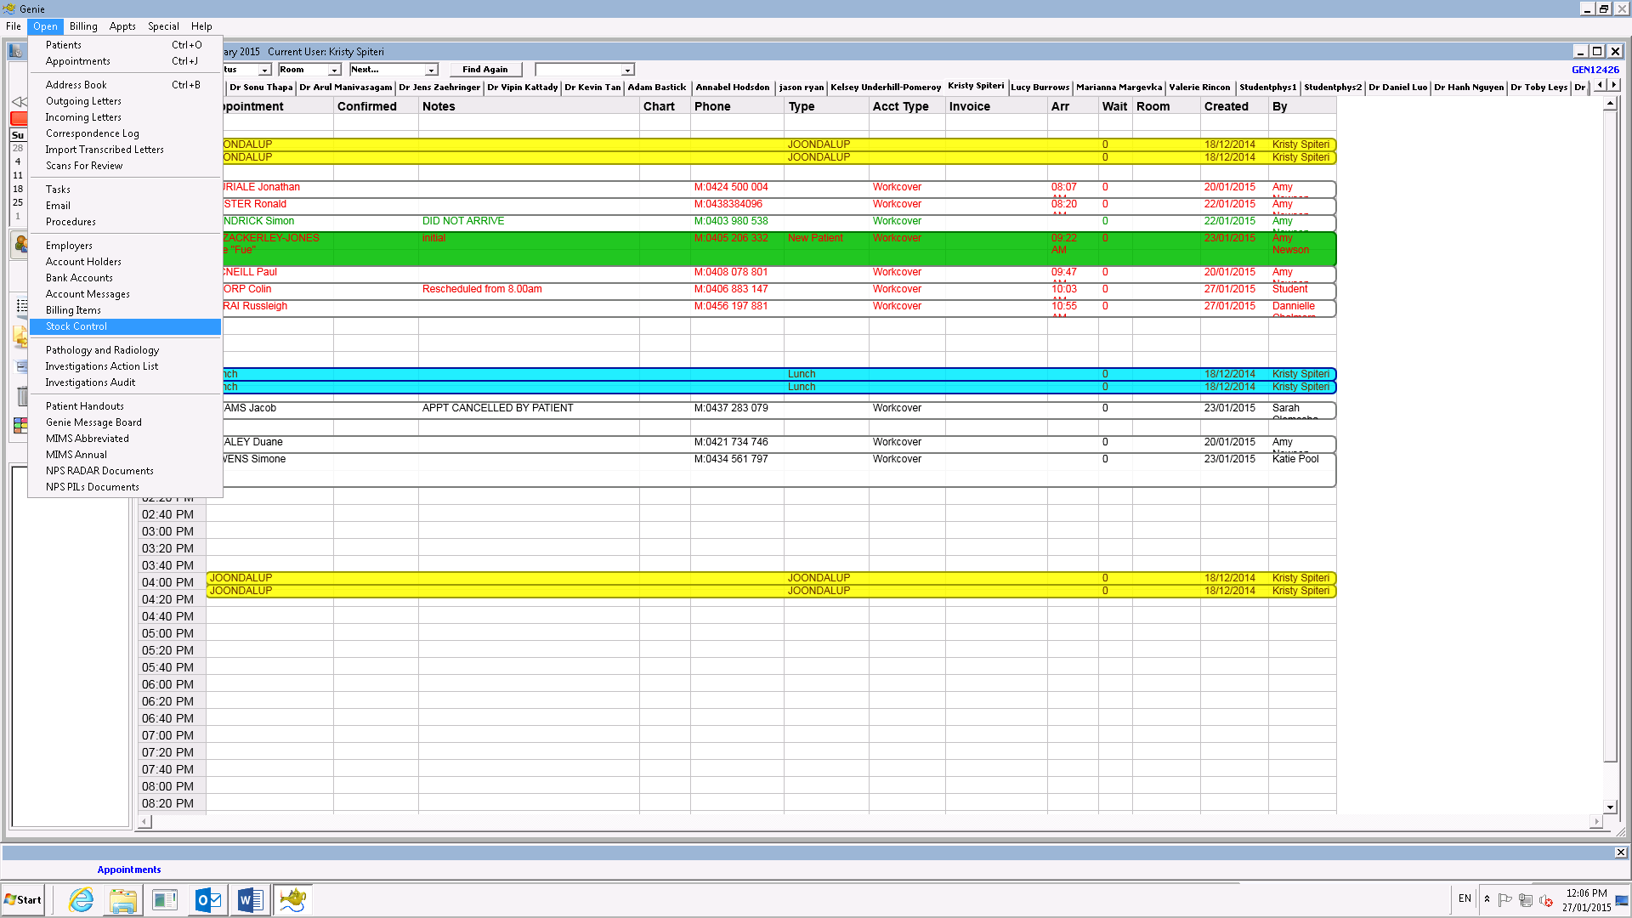

This window will appear:

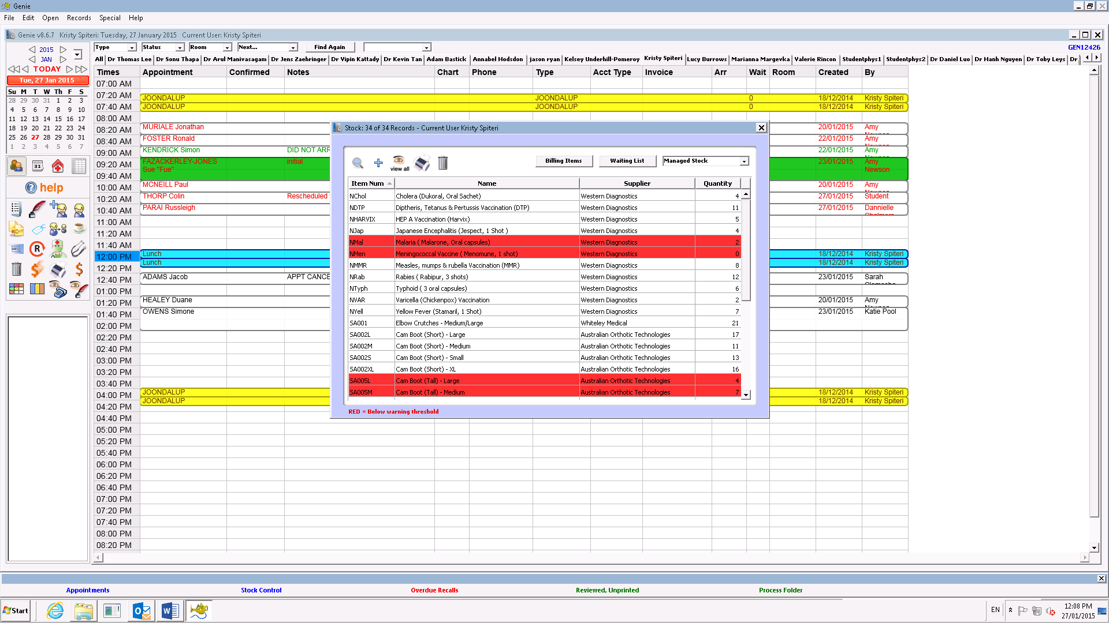

1. Scroll through the list of items and ensure the stock count for Belmont = the Quantity in Genie. Only physiotherapy items need to be checked.
2. List any discrepancies in an email to Team Leader and Kristy Spiteri ([kspiteri@redimed.com.au](mailto:kspiteri@redimed.com.au)) using the following template:

Hello Team Leader & Kristy,

Please find below a list of discrepancies found during the stock count on (insert date):

|  |  |  |  |
| --- | --- | --- | --- |
| Code | Item Description | Stock Count | Genie Qty |
| Eg. SA001 | Elbow Crutches | 12 | 14 |
|  |  |  |  |

Kind Regards

(Insert name)

**Entering stock into Genie:**

1. Use the invoice for the received stock to update Genie Stock Control.
2. Open the Genie Stock Control as in the Month Stock Level Check
3. Find the item you wish to amend and double click. This window will open:

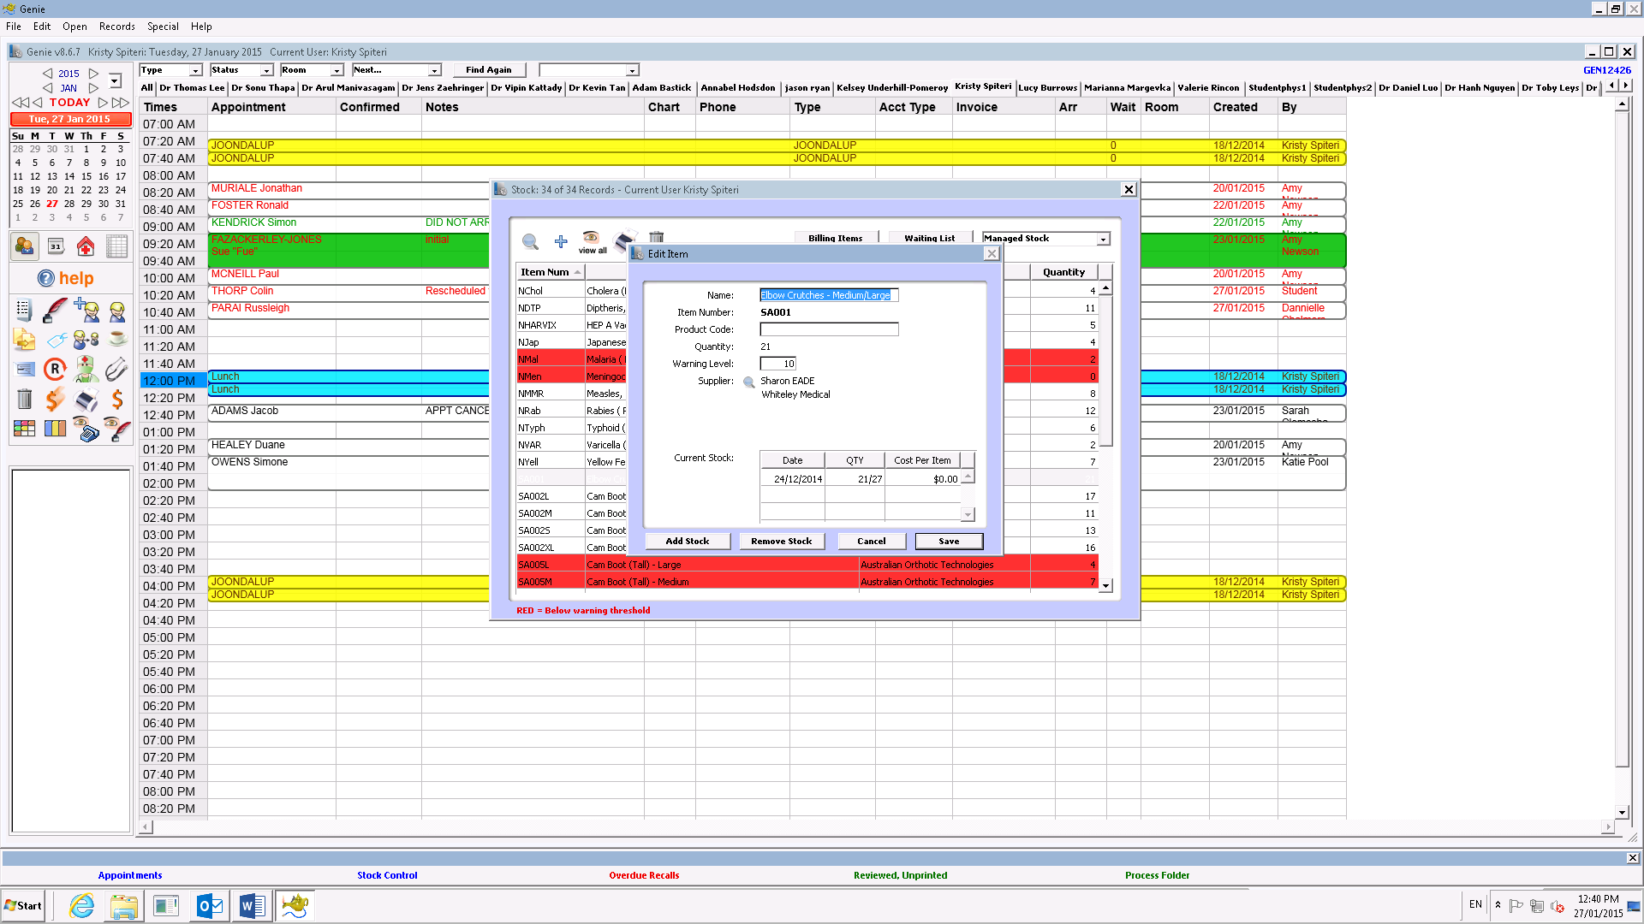

1. Click on Add Stock. This window will open:

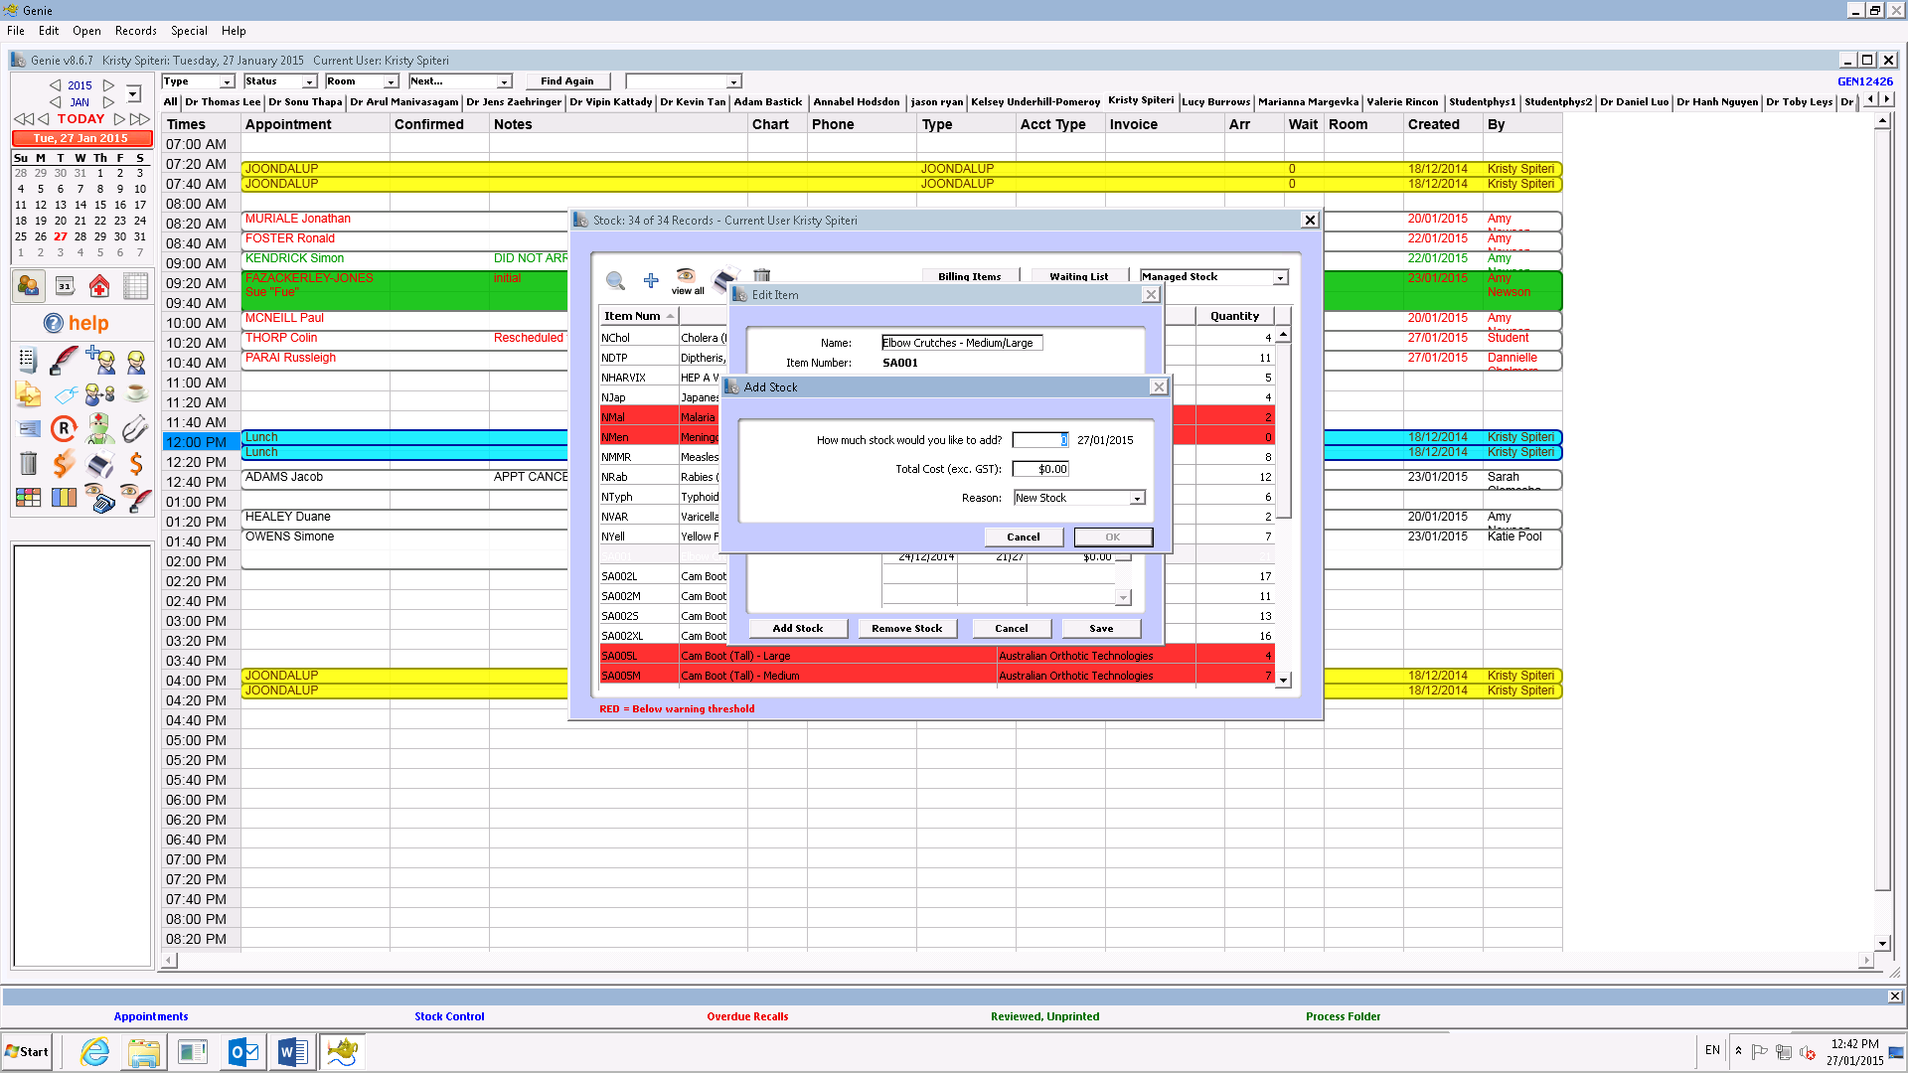

1. Enter the amount of stock received where indicated.
2. Enter the cost as per the invoice where indicated (excluding GST).
3. Select “New Stock” as the Reason.
4. Press Ok. This will take you back to this window.



1. Click Save.
2. Complete this process for all stock items received.

**Adding a New Item to Genie:**

1. Open Genie Stock Control as in the Monthly stock level check.
2. Check if the item already exists in Genie by clicking the small “+” icon in the top left corner. This window will open:

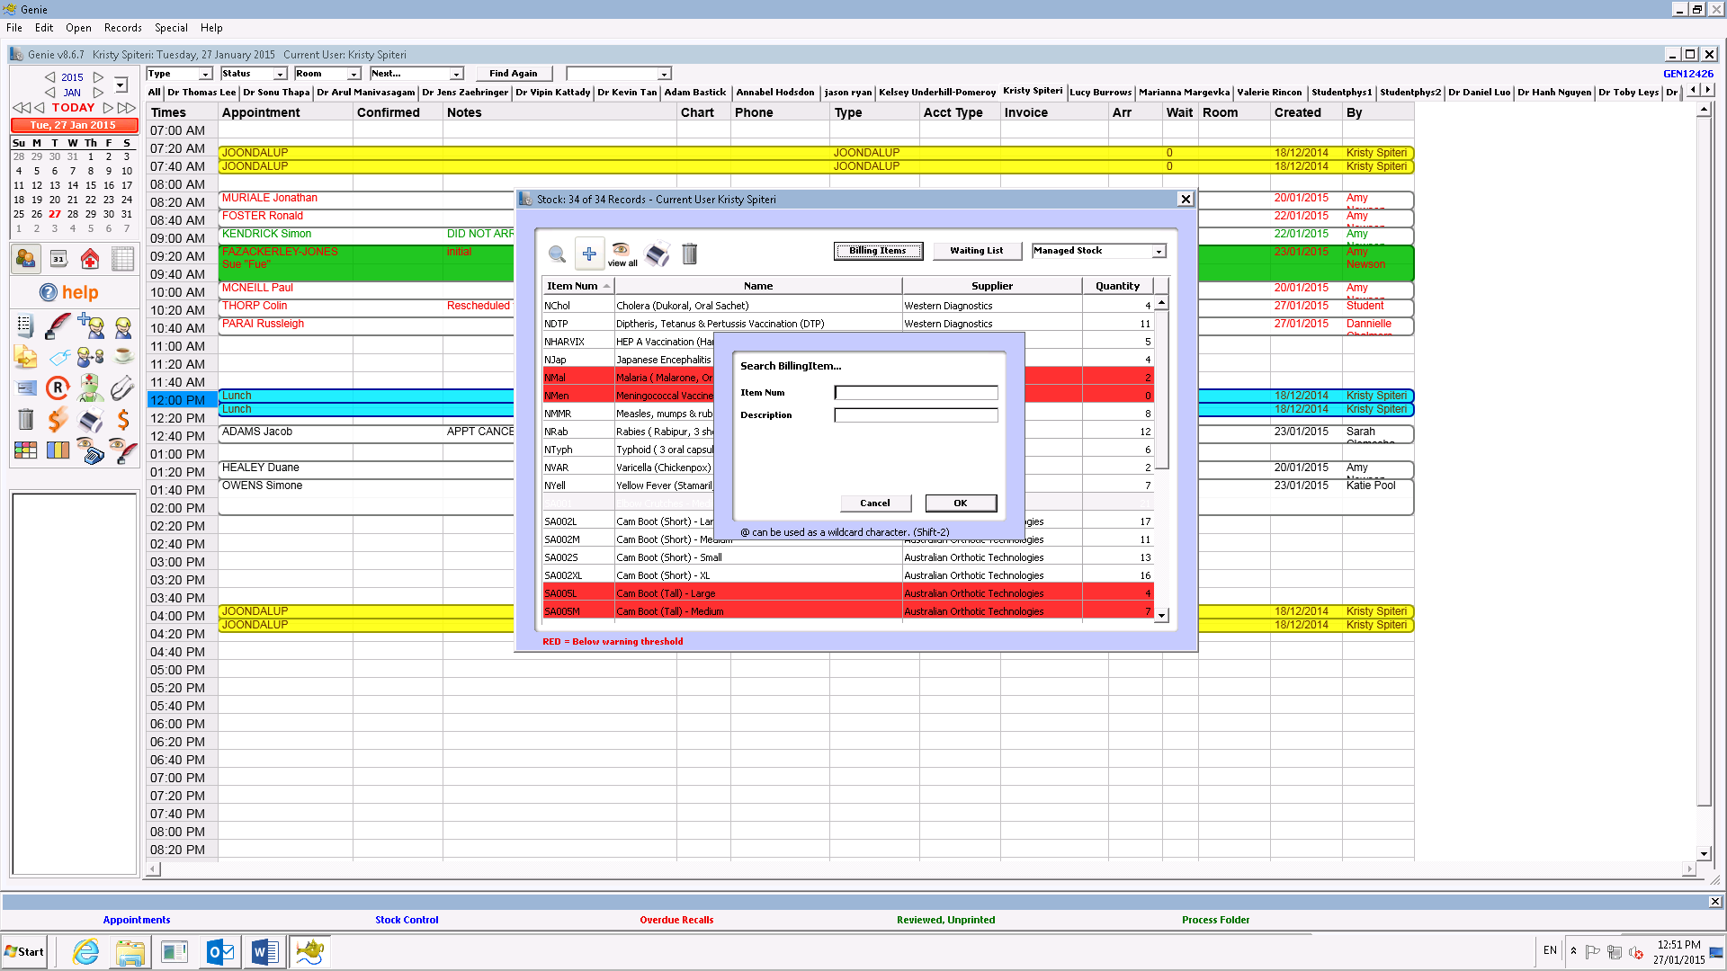

1. Enter the item number if known and press OK.
2. If there is no such item this window will open:

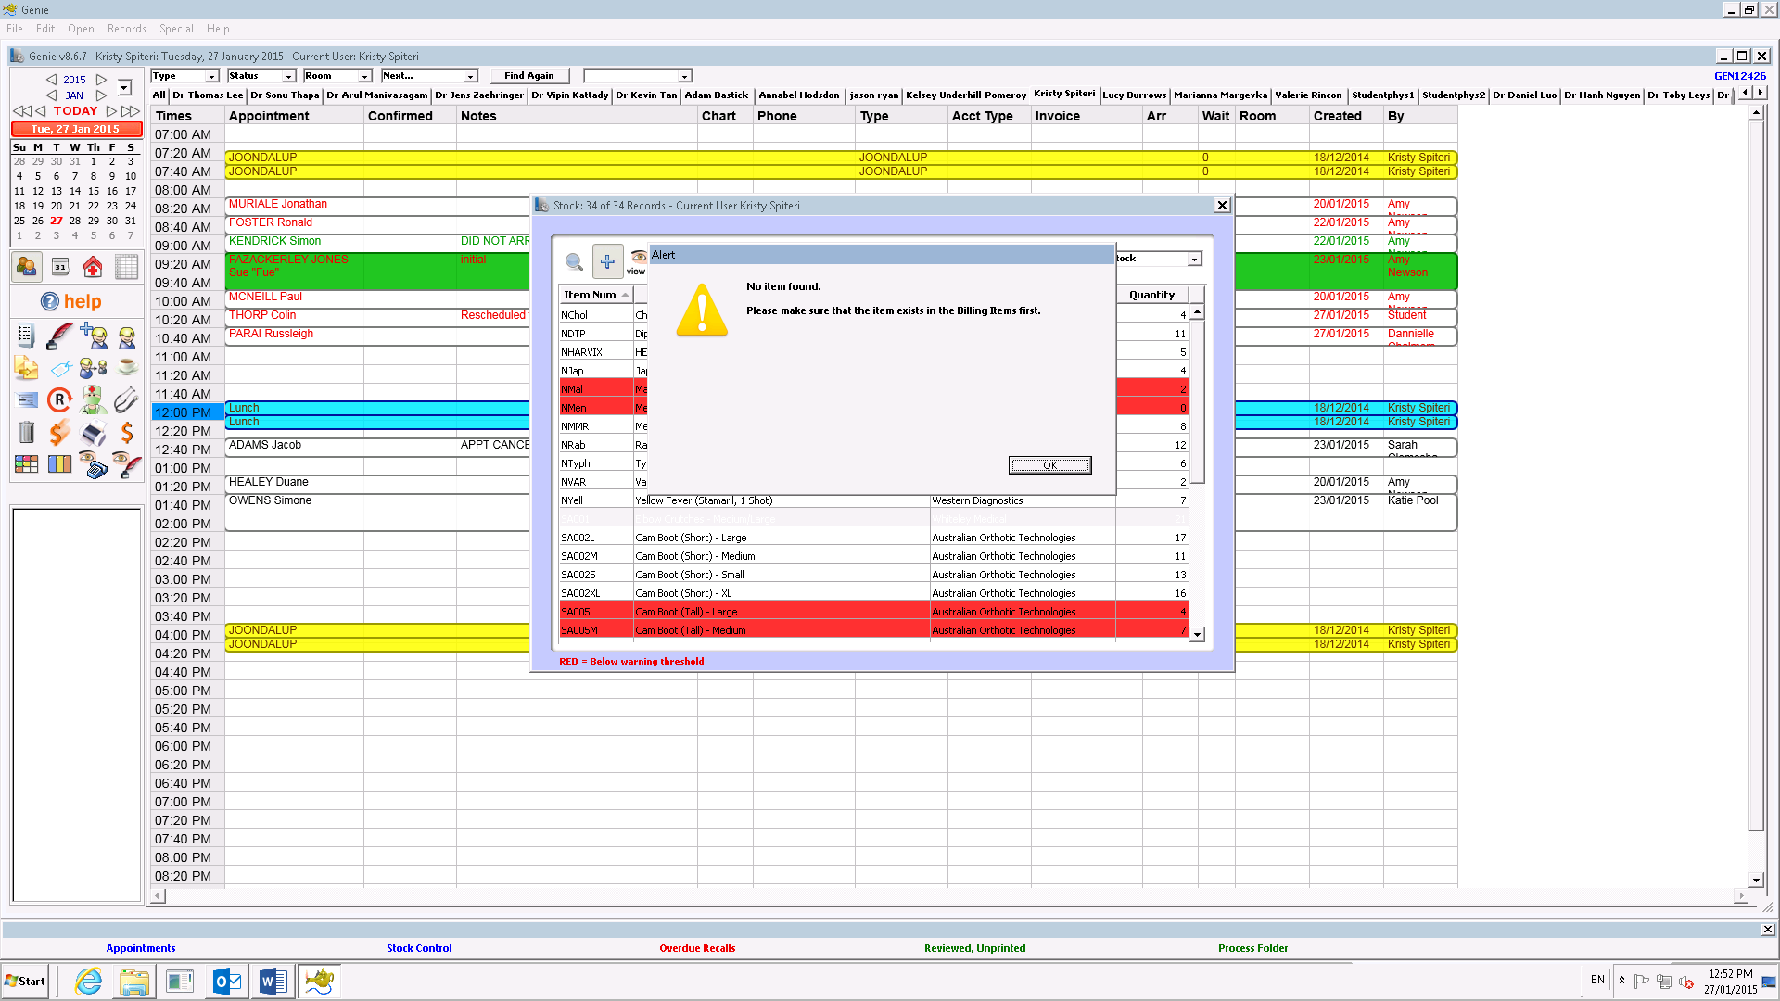

1. If there is an item in Genie but not in the Stock Control this window will open:

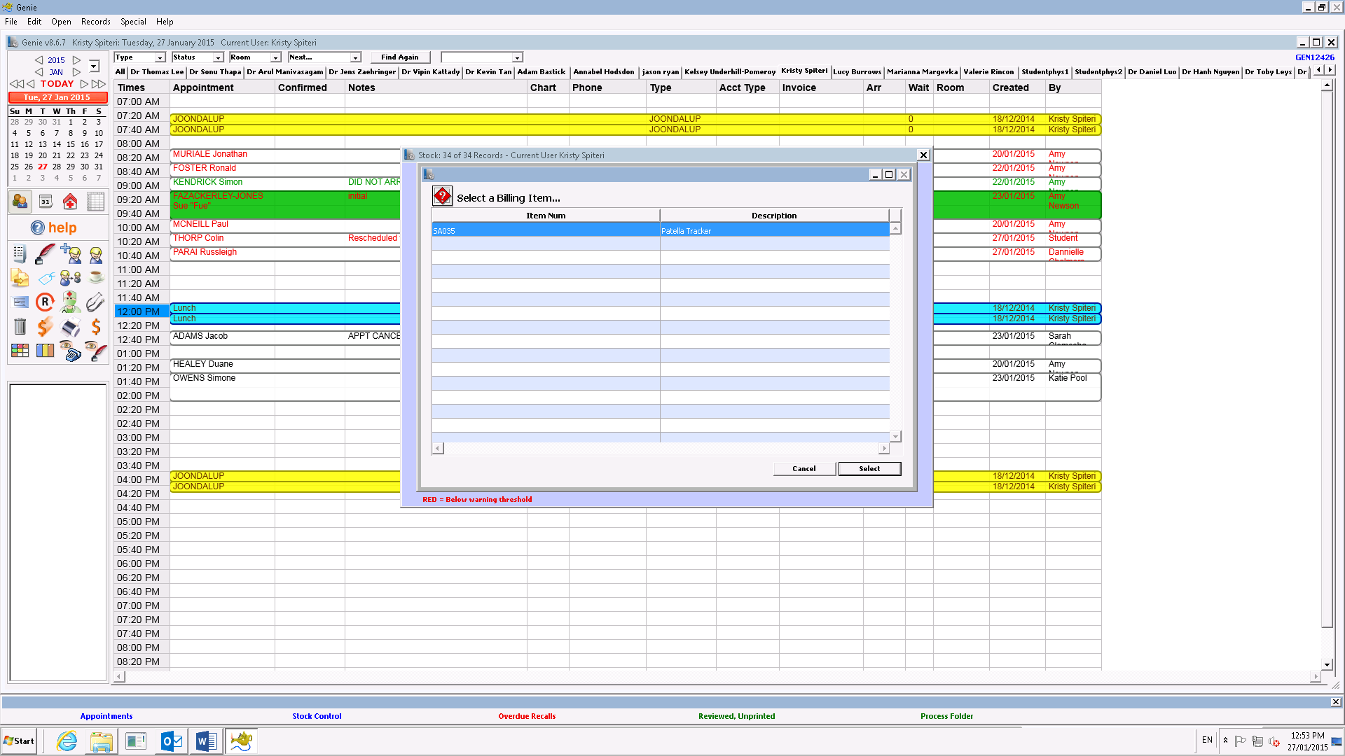

NOTE: If there is no item number known then it is likely to not be in Genie.

1. Click on Billing Items. This window will open:

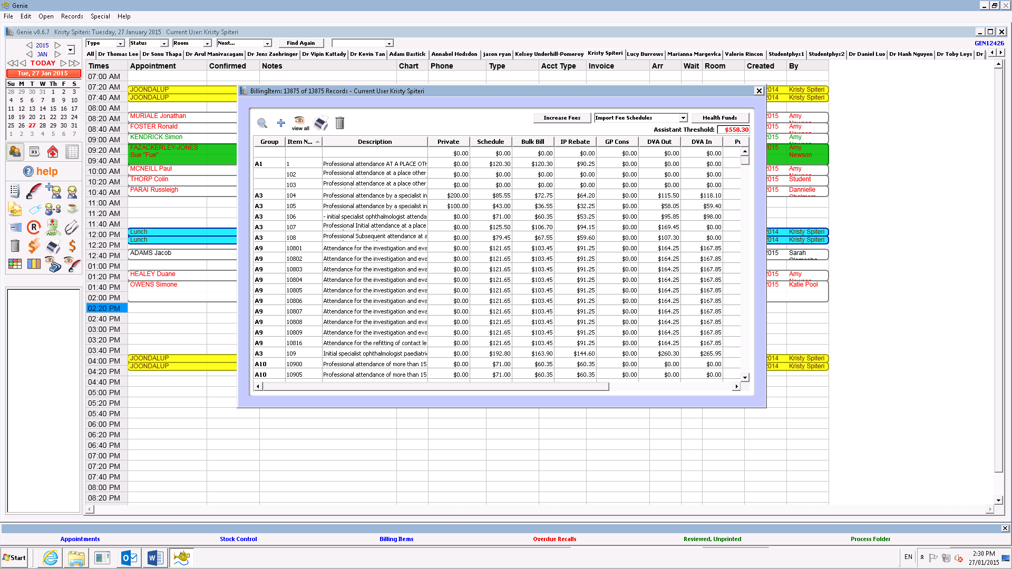

1. Click on the small “+” icon in the top left corner. This window will open:

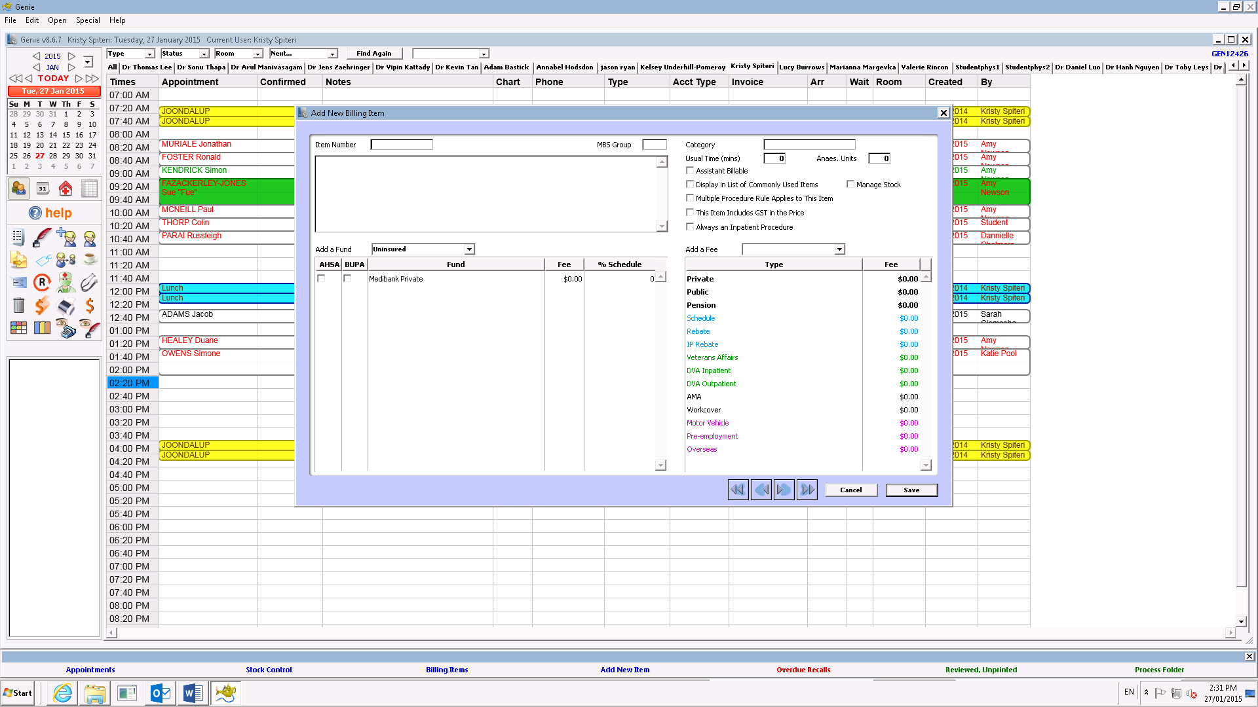

1. Enter the following information:
2. Item Number – Use a vacant code with SA followed by 3 numbers
3. Name the item in the large box under Item Number
4. Check “Display in List of Commonly Used Items” and “Manage Stock”
5. Private Fee
6. WorkCover Fee

NOTE: Fees are set as per the following:

|  |  |  |
| --- | --- | --- |
| Item Cost | Private Markup Rate | WorkCover Markup Rate |
| < / = $20 | 1.7 | 2.5 |
| >$20 | 1.5 | 2 |

1. Click Save.

# Appendices